FaceAlbum Design Decision

2017WS Praktikum Informatik 1

Zheng Li

0906101

Table of Contents

1 Project Overview 3

2 Scenarios 3

2.1 Use case diagram 3

2.2 Use Case List 3

2.3 Use case: Import photos into library 4

2.4 User case: Name detected faces 4

2.5 Use case: Correct wrong face recognition 5

2.6 Use case: Correct wrong emotion recognition 5

2.7 Use case: Browse photo library 6

2.8 Use case: Filter library by name 6

2.9 Use case: Filter library by Emotion 7

2.10 Use case: Filter library by text 7

2.11 Use case: Delete photo from library 8

2.12 Use case: Browse face gallery 9

2.13 Use case: Rename face 9

3 Data structure of the Database 10

4 Logical View 11

5 Development View 12

6 Process View 13

6.1 Import photos 13

# Project Overview

The main assignment of this project is to develop a photo gallery application with face recognition and emotion detection function using Python and Machine Learning. The aim is to find out a suitable approach for users to sort their photo gallery by face of people and the emotion of them.

The chosen programming language is Python3, additional framework and libraries are OpenCV, TensorFlow. The GUI will be created using QT5. The database choice of this project is Sqlite3.

# Scenarios

## Use case diagram

Figure 1 shows the use case diagram

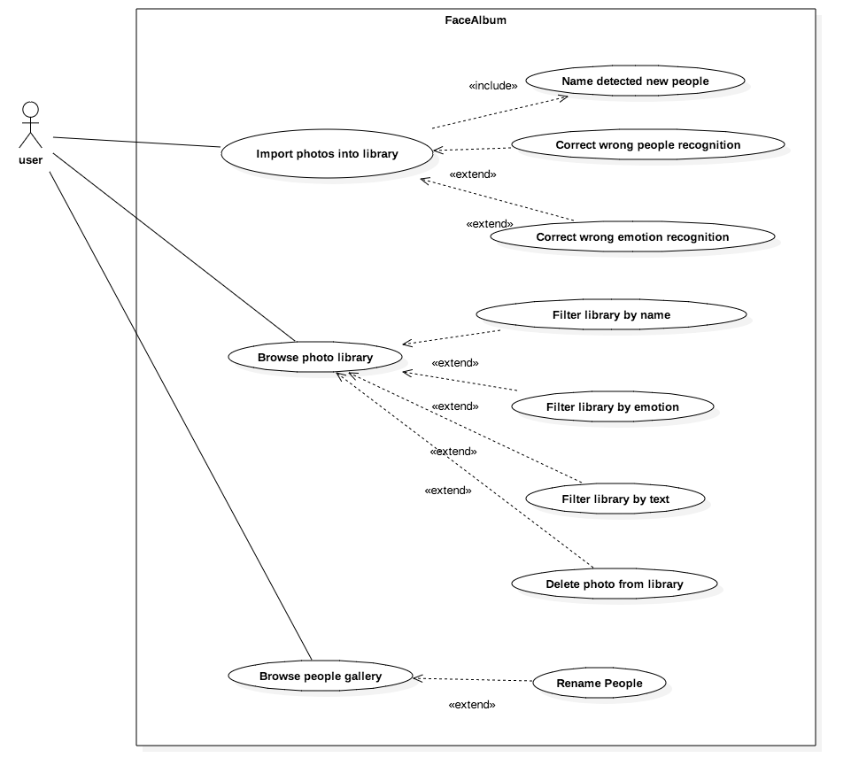

Figure 1 FaceAlbum Scenarios Use Case Diagram

## Use Case List

|  |  |
| --- | --- |
| Primary Actor | Use Cases |
| User | Import photos into library |
| User | Name detected people |
| User | Correct wrong people recognition |
| User | Correct wrong emotion recognition |
| User | Browse photo library |
| User | Filter library by name |
| User | Filter library by emotion |
| User | Filter library by text |
| User | Delete photo from library |
| User | Browse people gallery |
| User | Delete people from gallery |
| User | Rename face |

## Use case: Import photos into library

|  |  |
| --- | --- |
| Actors: | User |
| Description: | User can import new photos into the library. |
| Trigger: | Import button is clicked. |
| Preconditions: | * User provides a list of pictures files with compatible .format like JPG and PNG. * Picture can not be already included in the library. |
| Postconditions: | 1. Pictures are imported into the library database. 2. Tumbnails of pictures are generated. |
| Normal Flow: | 1. User clicks on „Import new photos“ button. 2. User selects a list of picture file. 3. User clicks import. |
| Alternative Flows: | None |
| Exceptions: | * File format is not compatible. * Picture already exists in library. |
| Includes: | * Name detected faces |
| Priority: | High |
| Frequency of Use: | Middle |
| Business Rules: | None |
| Special Requirements: | None |
| Assumptions: | None |
| Notes and Issues: | None |

## User case: Name detected people

|  |  |
| --- | --- |
| Actors: | User |
| Description: | User can give a name tag to a detected people during importing. |
| Trigger: | User clicks on the marked face in picture. |
| Preconditions: | * The detection of the face is correct. |
| Postconditions: | * The name tag of the face is stored in database. * The cropped out face picture is stored separately for later face recognition model training. |
| Normal Flow: | 1. User click on a detected face in the picture. 2. User give it a name. |
| Alternative Flows: | 1. User click on a detected face in the picture. 2. User informs that it is a wrong detection by clicking not a face button. |
| Exceptions: | None |
| Includes: | None |
| Priority: | High |
| Frequency of Use: | High |
| Business Rules: | None |
| Special Requirements: | None |
| Assumptions: | None |
| Notes and Issues: | None |

## Use case: Correct wrong people recognition

|  |  |
| --- | --- |
| Actors: | User |
| Description: | User can correct a wrong recognized face during importing. |
| Trigger: | Correct name button is clicked. |
| Preconditions: | 1. User decides that the recognized face is wrong. |
| Postconditions: | 1. The right name tag is assigned, and stored in the database. 2. Cropped face with the right name tag is ready for re-training of the face recognition model. |
| Normal Flow: | 1. User clicks on „wrong face“ button. 2. User gives the right name. 3. User clicks “correct” button. |
| Alternative Flows: | None |
| Exceptions: | Non |
| Includes: | None |
| Priority: | High |
| Frequency of Use: | Middle |
| Business Rules: | None |
| Special Requirements: | None |
| Assumptions: | None |
| Notes and Issues: | None |

## Use case: Correct wrong emotion recognition

|  |  |
| --- | --- |
| Actors: | User |
| Description: | User can correct a wrong recognized emotion during importing. |
| Trigger: | Correct emotion button is clicked. |
| Preconditions: | User decides that the recognized emotion is wrong. |
| Postconditions: | 1. The right emotion tag is assigned, and stored in the database. 2. Cropped face with the right emotion tag is ready for re-training of the emotion recognition model. |
| Normal Flow: | 1. User clicks on „wrong emotion“ button. 2. User gives the right emotion. 3. User clicks “correct” button. |
| Alternative Flows: | None |
| Exceptions: | Non |
| Includes: | None |
| Priority: | High |
| Frequency of Use: | Middle |
| Business Rules: | None |
| Special Requirements: | None |
| Assumptions: | None |
| Notes and Issues: | None |

## Use case: Browse photo library

|  |  |
| --- | --- |
| Actors: | User |
| Description: | User can browse the photos in the library. |
| Trigger: | „Browse library“ button is clicked. |
| Preconditions: | Library database is created. |
| Postconditions: | Photos in the library are shown in the gallery browser. |
| Normal Flow: | User click on “Browse library” botton.  Photos in the library are shown in the gallery browser. |
| Alternative Flows: | User click on “Browse library” botton.  Empty library is shown, application suggests user to import some photos. |
| Exceptions: | None |
| Includes: | None |
| Priority: | High |
| Frequency of Use: | Very High |
| Business Rules: | None |
| Special Requirements: | None |
| Assumptions: | None |
| Notes and Issues: | None |

## Use case: Filter library by name

|  |  |
| --- | --- |
| Actors: | User |
| Description: | User can filter the gallery by name tag. |
| Trigger: | User select a name tag from name tag filter. |
| Preconditions: | 1. Library database is created and has some photos imported. 2. Photo is already classified by the face recognition model. |
| Postconditions: | Photos with the right name tag in the library are shown in the gallery browser. |
| Normal Flow: | 1. User choose one name tag from name filter. 2. Photos with the right name tag in the library are shown in the gallery browser. |
| Alternative Flows: | None |
| Exceptions: | None |
| Includes: | None |
| Priority: | High |
| Frequency of Use: | Very High |
| Business Rules: | None |
| Special Requirements: | None |
| Assumptions: | None |
| Notes and Issues: | None |

## Use case: Filter library by Emotion

|  |  |
| --- | --- |
| Actors: | User |
| Description: | User can filter the gallery by emotion tag. |
| Trigger: | User select a emotion tag from emotion tag filter. |
| Preconditions: | 1. Library database is created and has some photos imported. 2. Photo is already classified by the emotion recognition model. |
| Postconditions: | Photos with the right emotion tag in the library are shown in the gallery browser. |
| Normal Flow: | 1. User choose one emotion tag from emotion filter. 2. Photos with the right emotion tag in the library are shown in the gallery browser. |
| Alternative Flows: | None |
| Exceptions: | None |
| Includes: | None |
| Priority: | High |
| Frequency of Use: | Very High |
| Business Rules: | None |
| Special Requirements: | None |
| Assumptions: | None |
| Notes and Issues: | None |

## Use case: Filter library by text

|  |  |
| --- | --- |
| Actors: | User |
| Description: | User can filter the gallery by a free text input. |
| Trigger: | User give a text description of the filter. |
| Preconditions: | 1. Text are simple, consist of the names and emotions of the search. 2. Text contains the name and the emotion that the user want to search for, for example like “Steve Marry happy”. 3. Text does not contain complicate logical words, for example like “Steve and Marry are both not very happy”. |
| Postconditions: | Photos with the right name and emotion tag in the library are shown in the gallery browser. |
| Normal Flow: | 1. User types in the text and click filter. 2. Photos with the right name and emotion tag in the library are shown in the gallery browser. |
| Alternative Flows: | None |
| Exceptions: | None |
| Includes: | None |
| Priority: | High |
| Frequency of Use: | Very High |
| Business Rules: | None |
| Special Requirements: | None |
| Assumptions: | None |
| Notes and Issues: | None |

## Use case: Delete photo from library

|  |  |
| --- | --- |
| Actors: | User |
| Description: | User can delete photos in the library. |
| Trigger: | „Delete“ button is clicked. |
| Preconditions: | None |
| Postconditions: | Picture deleted from library |
| Normal Flow: | 1. User click on “Delete” botton. 2. Picture entries of the photo is deleted in pictures table in database. 3. Faces in that picture is also deleted in faces table in database. |
| Alternative Flows: | None |
| Exceptions: | None |
| Includes: | None |
| Priority: | Middle |
| Frequency of Use: | Middle |
| Business Rules: | None |
| Special Requirements: | None |
| Assumptions: | None |
| Notes and Issues: | None |

## Use case: Browse people gallery

|  |  |
| --- | --- |
| Actors: | User |
| Description: | User can browse the faces already identified in the library. |
| Trigger: | „Browse faces“ button is clicked. |
| Preconditions: | At least one face can be identified by the model . |
| Postconditions: | Faces in the library are shown in the gallery browser. |
| Normal Flow: | 1. User click on “Browse faces” botton. 2. Faces in the library are shown in the gallery browser. |
| Alternative Flows: | 1. User click on “Browse faces” botton. 2. Empty library is shown, application suggests that there are still not enough data collected. |
| Exceptions: | None |
| Includes: | None |
| Priority: | High |
| Frequency of Use: | Very High |
| Business Rules: | None |
| Special Requirements: | None |
| Assumptions: | None |
| Notes and Issues: | None |

## Use case: Rename people

|  |  |
| --- | --- |
| Actors: | User |
| Description: | User can rename faces in the gallery. |
| Trigger: | „Rename“ button is clicked. |
| Preconditions: | None |
| Postconditions: | Faces is renamed. |
| Normal Flow: | User click on “Rename” botton.  Name_tag entry of that face is renamed. |
| Alternative Flows: | None |
| Exceptions: | None |
| Includes: | None |
| Priority: | Middle |
| Frequency of Use: | Middle |
| Business Rules: | None |
| Special Requirements: | None |
| Assumptions: | None |
| Notes and Issues: | None |

# Data structure of the Database

Figure 2 shows the ER-diagram of the data structure.

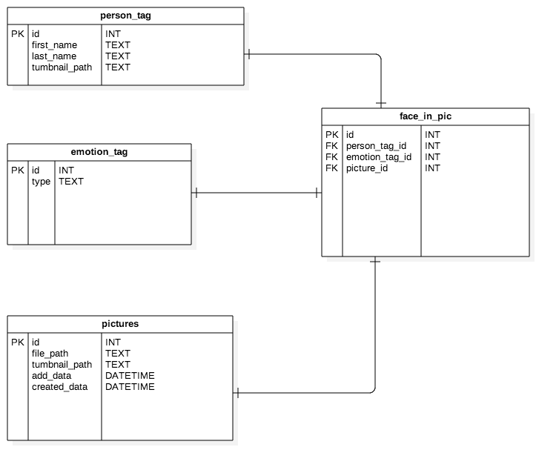

Figure 2 ER-diagram of the data structure

# Logical View

Figure3 shows the class diagram

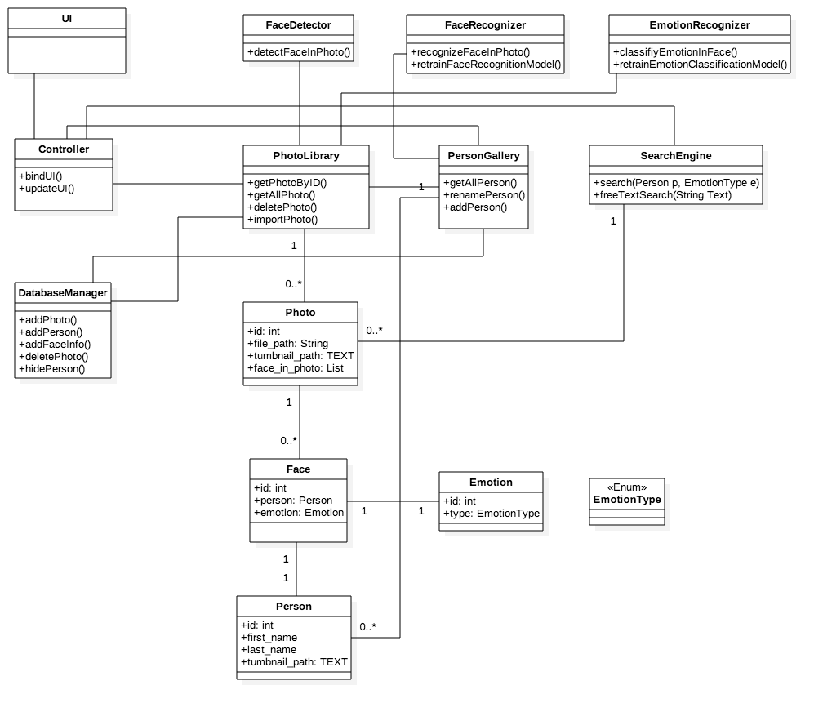

Figure 3 Class diagram

# Development View

Figure 4 shows the component diagram.

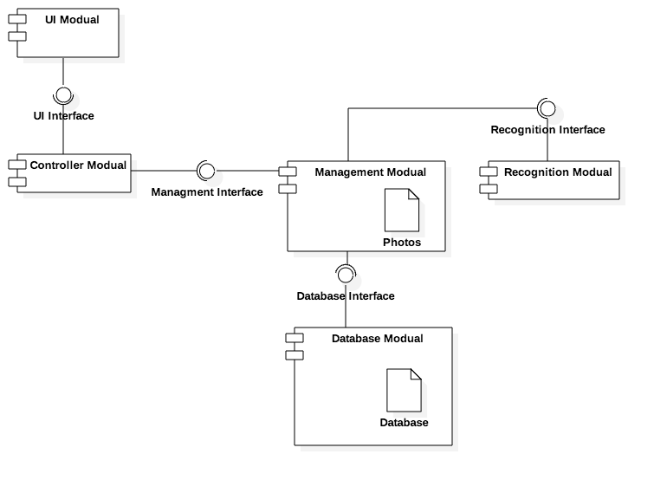

Figure 4 Component diagram

# Process View

## Import photos

Figure 5 shows the activity diagram of importing photos.

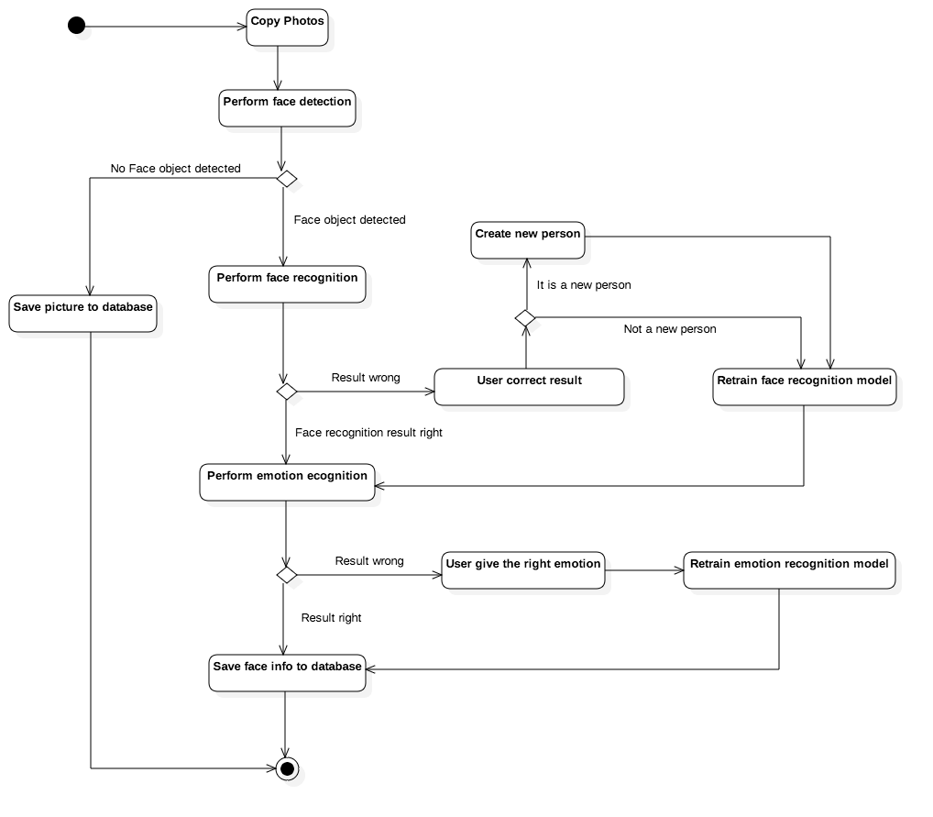

Figure 5 Activity diagram - import photos